**Batch: A-3 Roll No.: 16010122104**

**Experiment / assignment / tutorial No.3**

**Grade: AA / AB / BB / BC / CC / CD /DD**

**Signature of the Staff In-charge with date**

**Experiment No.:3**

|  |
| --- |
| **TITLE:** Building and configuring simple topology using Network tool - CISCO PACKET TRACER. |

**______________________________________________________________________________**

**AIM:** To build and configure simple network topology using CISCO Packet Tracer.

Packet Tracer is a network simulation program that allows students to experiment with network behaviour and ask “what if” questions. Packet Tracer provides simulation, visualization, and authoring, assessment, and collaboration capabilities and facilitates the teaching and learning of complex technology concepts.

**______________________________________________________________________________**

**Expected Outcome of Experiment:**

**CO:**

**_____________________________________________________________________________**

**Books/ Journals/ Websites referred:**

1. <http://www.google.com>
2. A. S. Tanenbaum, “Computer Networks”, Pearson Education, Fourth Edition
3. B. A. Forouzan, “Data Communications and Networking”, TMH, Fourth Edition
4. [CISCO PACKET TRACER 8.0.1 and Higher version (free download)](https://mega.co.nz/#!q4p0wS7Z!J9jkMwXzZSO4zP1kZX632VFYyxNzwPUhvx8f8Ejyen0 (53.3 MB))

**Pre-Lab/ Prior Concepts:** Simple Network flow

**______________________________________________________________________________**

**New Concepts to be learned**: Purpose of this lab is to become familiar with building topologies in Packet Tracer. ______________________________________________________________________________

**Stepwise-Procedure:**

Creating a simple LAN network using packet tracer:

Step 1: Select two PCs (PC0 and PC1) from the end devices and one fast ethernet switch (2950/24 ports)

Step 2: Connect PCs and switch via copper cable from the panel. Connection can be verified by appearance of all green dots on the links.

Step 3: For PCs to communicate click on PC0.

* Dialog box for PC0 appears
* Click on desktop applications by packet tracer.
* Go to IP configuration.
* Enter IP address to identify host i.e. PC0 (for example: 192.168.1.1)
* Subnet mask-by default already set one can change it as per his/her specification.

Step 4: Repeat step 3 for PC1

Step 5: Ping both the PCs and check their working status.

Step 6: Simple PDU (Protocol Data Unit) to simulate network traffic by sending ICMP PDU to assess the network traffic. View simulation in simulation mode

**IMPLEMENTATION:** (printout of simulation code)

**Network Topologies:**

1. **Topology with a HUB**

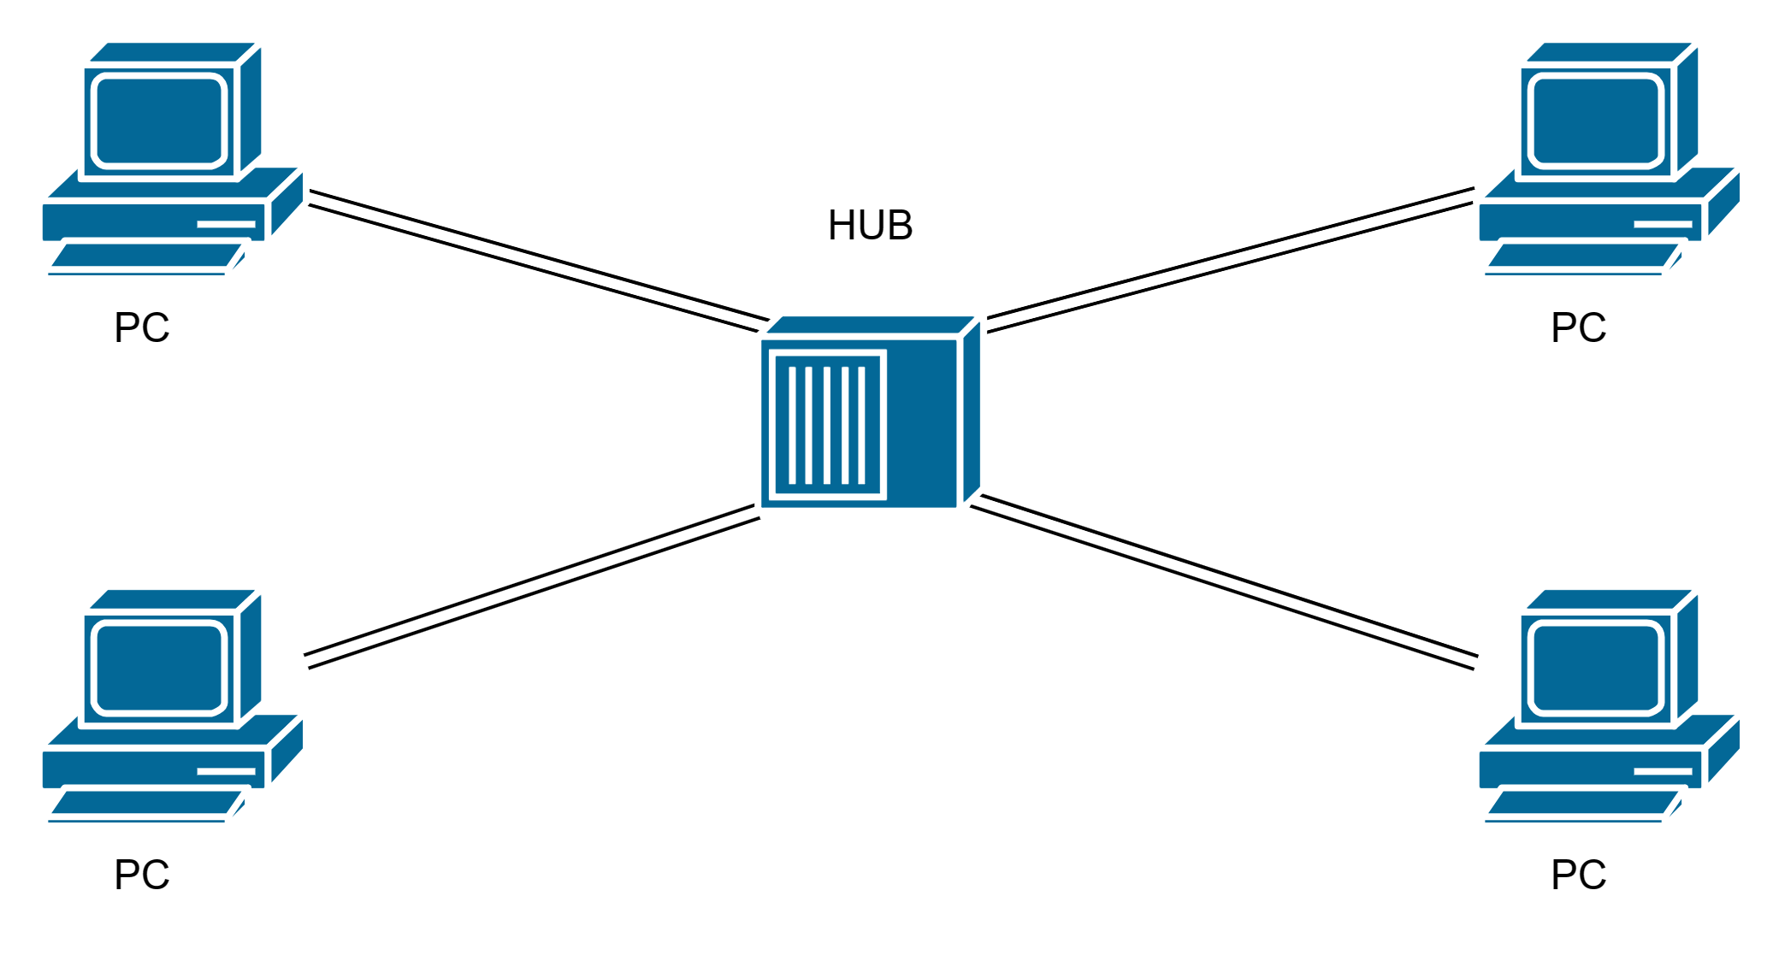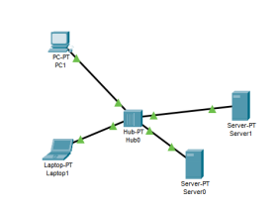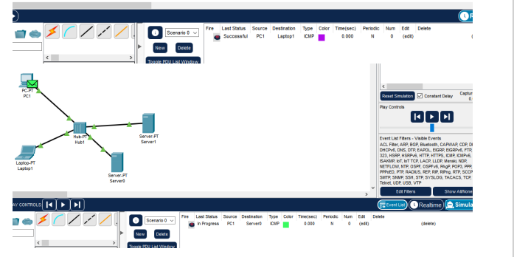

**2. Topology with a Switch**

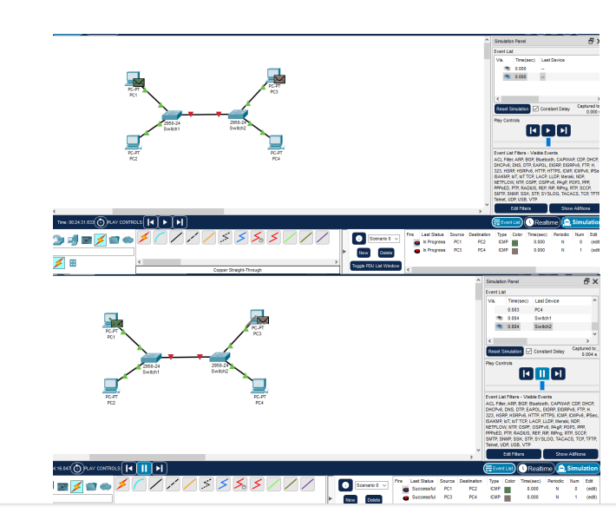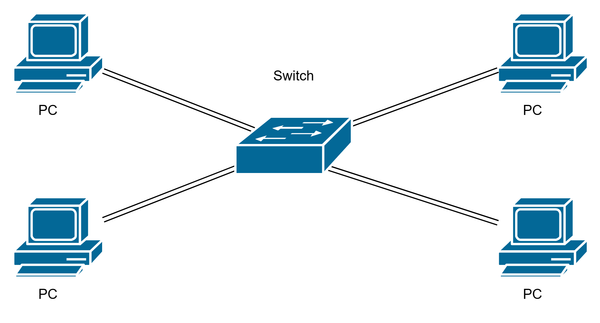

**3. Topology with two switches**

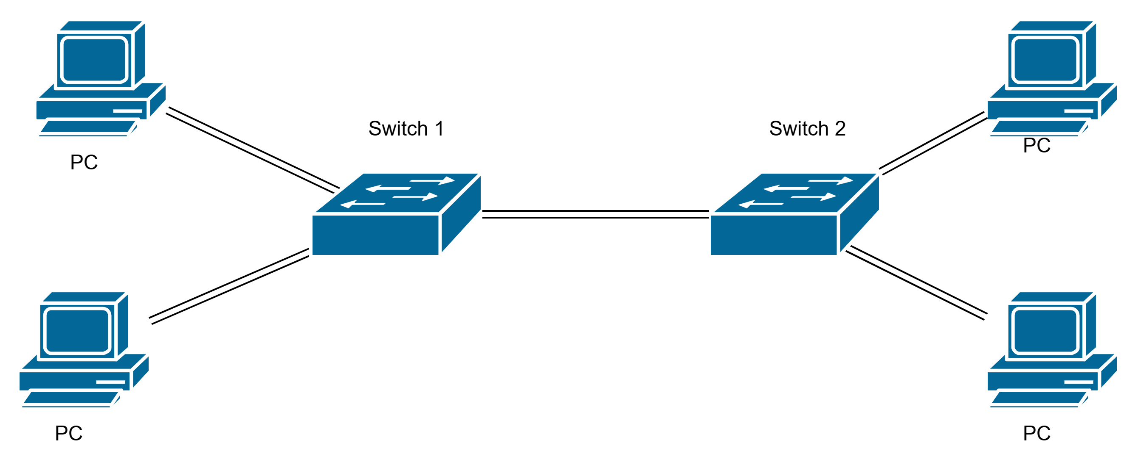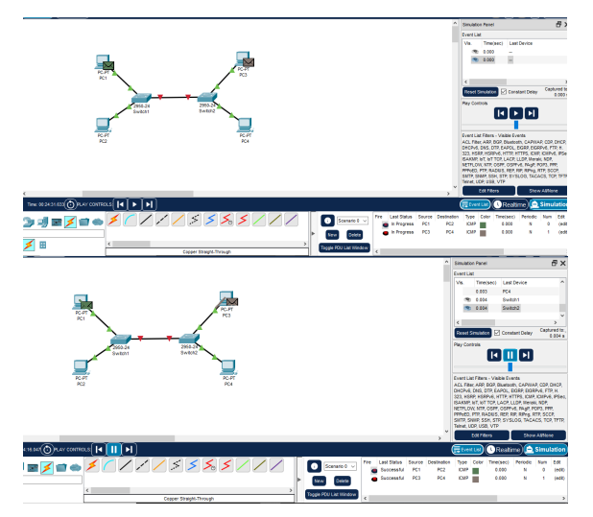

1. **Topology with 3 switches in a loop (Concept of STP)**

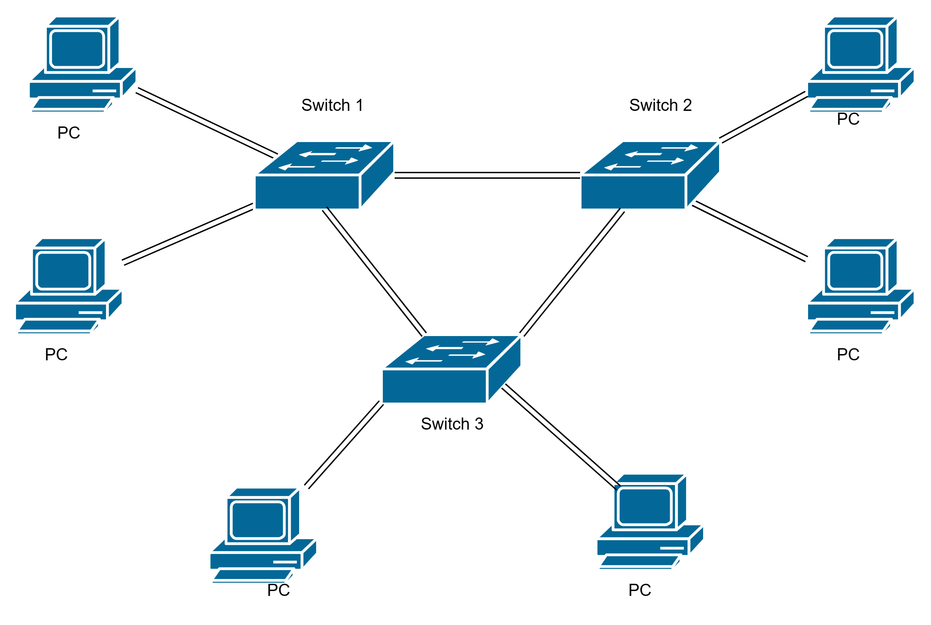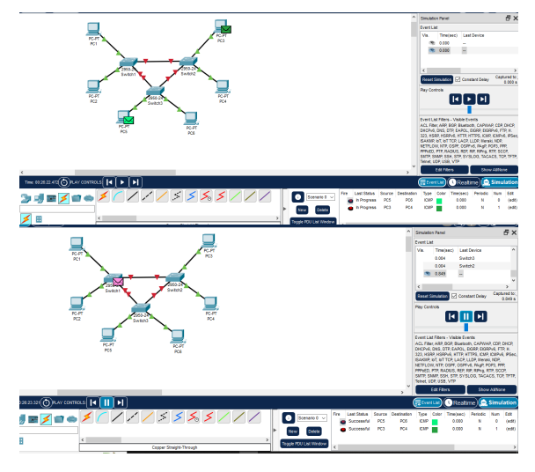

**CONCLUSION:**

Using Cisco Packet Tracer, we successfully built and configured a simple network topology, demonstrating the tool's effectiveness in designing and managing network configurations.

**Post Lab Questions**

1. **List features of CISCO packet tracer.**

**Ans:**

* Network simulation and modelling
* Packet capture and analysis
* Support for a wide range of Cisco devices
* Interactive network design o Real-time and simulated network performance monitoring
* Troubleshooting tools and diagnostics
* Support for various network topologies
* Configuration and management of network devices
* Integration with Cisco’s learning materials and curriculum
* Virtual network labs and practice exercises

1. **Explain difference between working of a Hub and a Switch in a given topology.**

**Ans:**

| **HUB** | **SWITCH** |
| --- | --- |
| [Hub](https://www.geeksforgeeks.org/advantages-and-disadvantages-of-hub/) is operated on **Physical layer of OSI model**. | While [switch](https://www.geeksforgeeks.org/what-is-a-network-switch-and-how-does-it-work/) is operated on **Data link**[**layer of OSI Model**](https://www.geeksforgeeks.org/layers-of-osi-model/). |
| Hub is a broadcast type transmission. | While switch is a Unicast, multicast and broadcast type transmission. |
| Hub have 4/12 ports. | While switch can have 24 to 48 ports. |
| In hub, there is only one collision domain. | While in switch, different ports have own collision domain. |
| Hub is a half duplex transmission mode. | While switch is a full duplex transmission mode. |
| In hub, Packet filtering is not provided. | While in switch, Packet filtering is provided. |
| Hub cannot be used as a repeater. | While switch can be used as a repeater. |
| Hub is not an intelligent device that sends message to all ports hence it is comparatively inexpensive. | While switch is an intelligent device that sends message to selected destination so it is expensive. |
| Hub is simply old type of device and is not generally used. | While switch is very sophisticated device and widely used. |
| Hacking of systems attached to hub is complex. | Hacking of systems attached to switch is little easy. |
| Speed of original hub 10Mbps and modern internet hub is 100Mbps. | Maximum speed is 10Mbps to 100Mbps. |
| Hubs are used in LANs. | Switch is used in LANs. |
| Cheaper as compared to switch. | Expensive as compared to HUB. |

**Date: 05/08/2024 Signature of faculty in-charge**